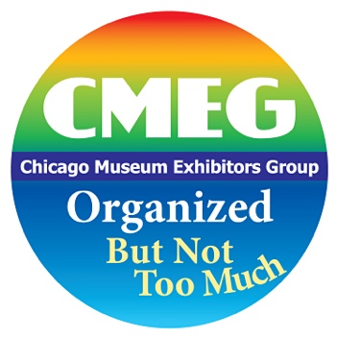

The events of the recent months have forced the nation to grapple with longstanding questions of injustice and inequity that affect Black, Indigenous, and People of Color (BIPOC).

We’d like to explore with our members what we all can do to move beyond statements of support and take action to help achieve greater diversity, equity, accessibility, and inclusion (DEAI) within CMEG and all of our museums, cultural institutions, and companies.

When the #BLM protests began, members of the CMEG Steering Committee started thinking about how we could show support in a meaningful way. We decided, in line with our mission, to create a virtual program that addressed anti-racism and DEAI work in museums. And, the more we discussed the program, the clearer it became that we needed to consider DEAI in our own organization if we wanted to talk about these issues in museums at large.

The virtual meeting happened on September 24, and the large number of members who viewed it makes it clear that our community is invested in this topic. Now we are creating a DEAI committee to consider how we can deal with these issues within CMEG.

If you’d like additional information now or are already interested in joining the CMEG DEAI committee, please click here: https://forms.gle/7rs8GebCSGyDnwin8

Thank you! We hope you are as excited as we are to take these steps.

Sincerely,
The CMEG Steering Committee

